TRIMS ERP

(SUPPLIER ASSESSMENT FORM)

1. DATA ENTERED IN MASTER TABLE AND THE SUPPLIER CODE GENERATED:

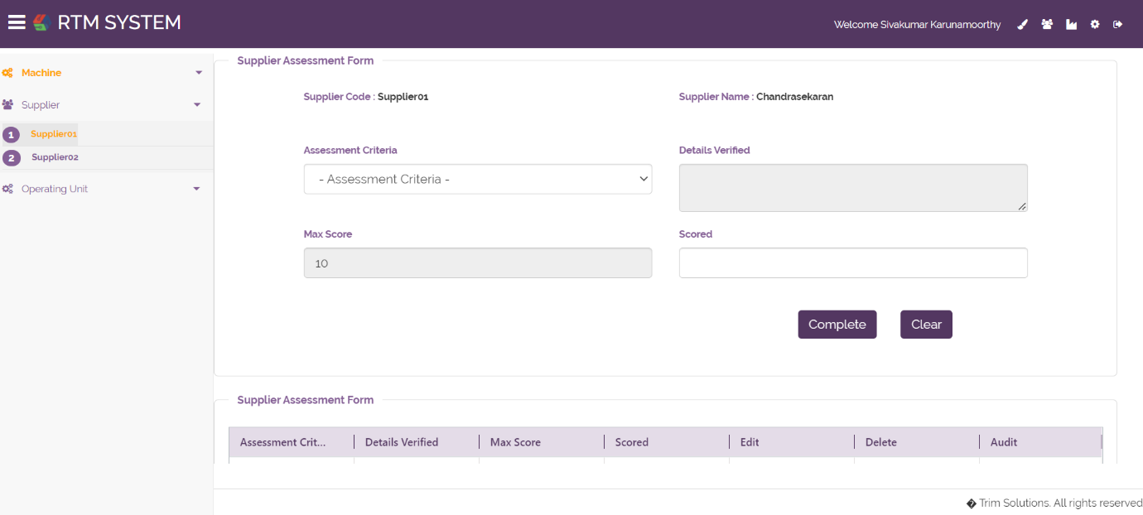

1. SELECT DROPDOWN FOR ASSESSTMENT CRITERIA THE DETAILS VERIFIED COLUMN SET AUTOMATICALLY:



1. DATA STORED MANUALLY:

